**WeatherPy Trends**

1. **City Coverage Plot :** This plot shows that a considerable good coverage of lats and longs are selected for the analysis from across the world. 607 cities were randomly selected from 1500 lat lngs. Fewer cities towards south pole were selected compared to north pole. ( A total of 520 cities was used after skipping cities that were not found)

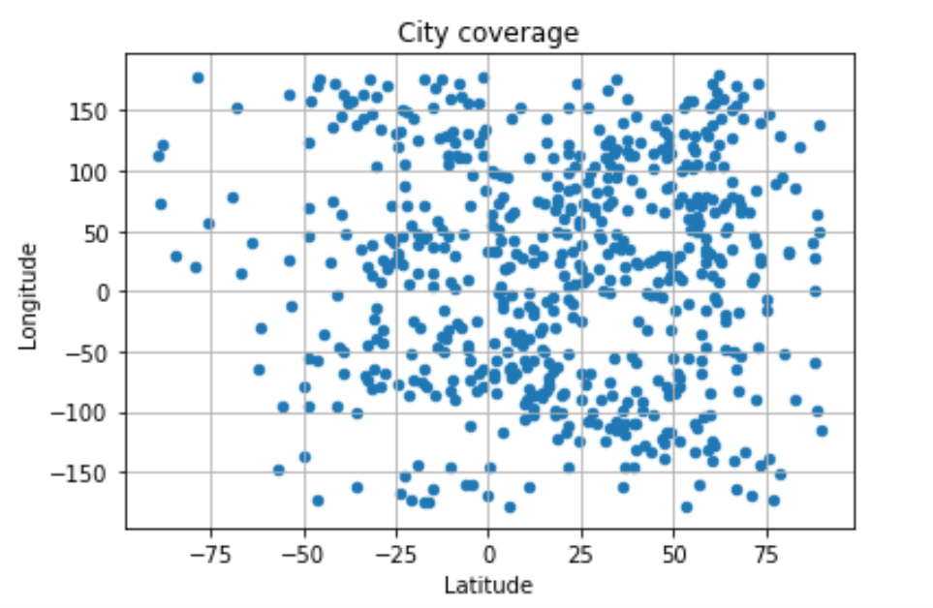

1. **City Latitude Vs Temp Plot :** Based on the plot , cities between equator (0 deg) and 20+ deg north records the highest temperature , as the cities move further away to north or south pole the temperatures drop

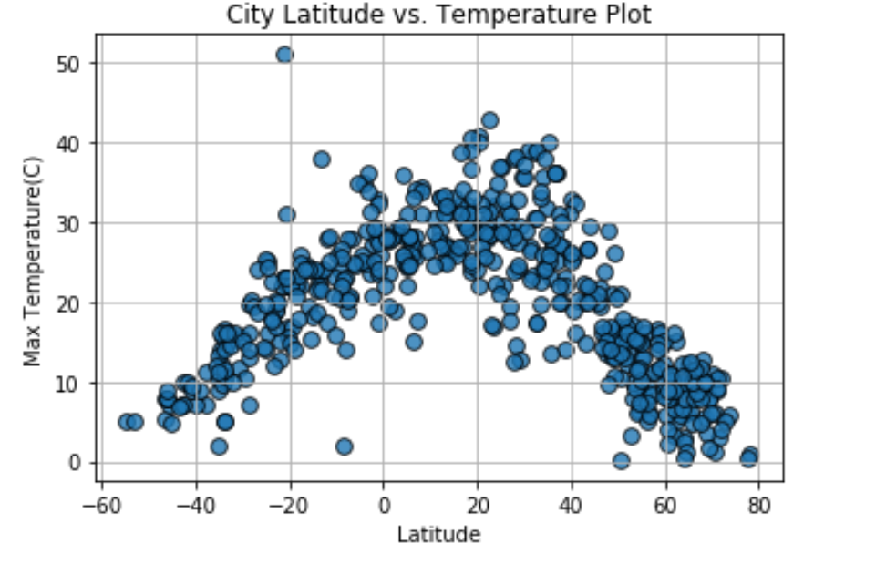

1. **City Latitude vs. Wind Speed Plot:** Based on the plot , wind speed is uniform in cities closer to the equator and is varied as it moves further north or south

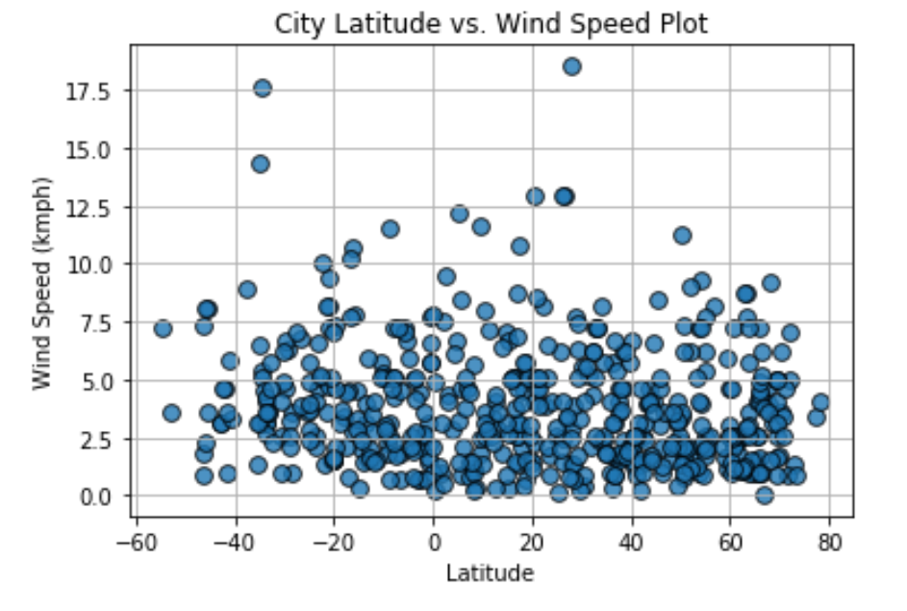

1. **City Latitude vs. Humidity Plot:** Based on the plot , cities closer to the equator have less variation in humidity compared to cities further towards north and south pole

